Experiment: Implementation of K-Nearest Neighbours (K-NN) in Python
Aim
To implement the K-Nearest Neighbours (K-NN) algorithm in Python and classify the test samples using the Iris dataset.
Theory
The K-Nearest Neighbours (K-NN) algorithm is a supervised machine learning algorithm used for classification and regression. It classifies a new data point based on the majority class among its K nearest neighbors.
Steps:
- Choose the value of K.
- Calculate the distance between the test sample and all training samples.
- Select the K nearest neighbors.
- Assign the class that appears most frequently among the neighbors.
Procedure
- Import the required Python libraries.
- Load the Iris dataset.
- Split the dataset into training and testing sets.
- Create the K-NN classifier with a suitable value of K.
- Train the classifier using the training data.
- Predict the class labels for the test data.
- Calculate the accuracy of the model.
- Display the actual and predicted values.
Python Program
from sklearn.datasets import load_iris
from sklearn.model_selection import train_test_split
from sklearn.neighbors import KNeighborsClassifier
from sklearn.metrics import accuracy_score
# Load Iris dataset
iris = load_iris()
X = iris.data
y = iris.target
# Split dataset into training and testing
X_train, X_test, y_train, y_test = train_test_split(
X, y, test_size=0.3, random_state=1
)
# Create K-NN classifier
knn = KNeighborsClassifier(n_neighbors=3)
# Train the model
knn.fit(X_train, y_train)
# Predict the test data
y_pred = knn.predict(X_test)
# Display results
print("Actual Values:")
print(y_test
print("\nPredicted Values:")
print(y_pred)
print("\nAccuracy:", accuracy_score(y_test, y_pred))Output
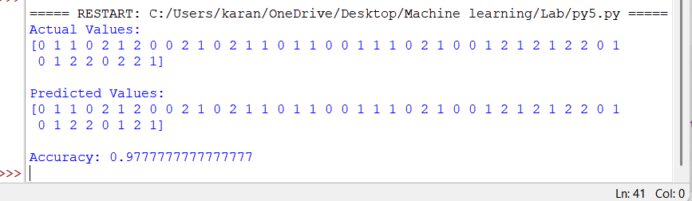Result
The K-Nearest Neighbours (K-NN) algorithm was successfully implemented in Python. The classifier was trained and tested on the Iris dataset, and it predicted the class labels with high accuracy.

